wmic path SoftwareLicensingService get OA3xOriginalProductKey

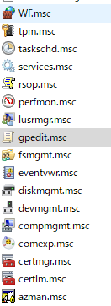

regedit.exe

msinfo32.exe

Netplwiz.exe

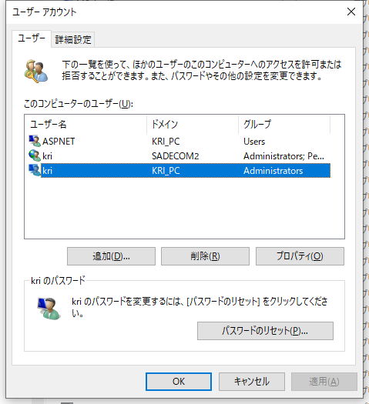

OptionalFeatures.exe

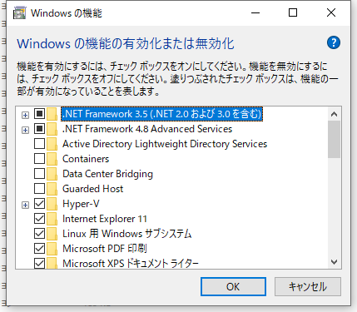

osk.exe

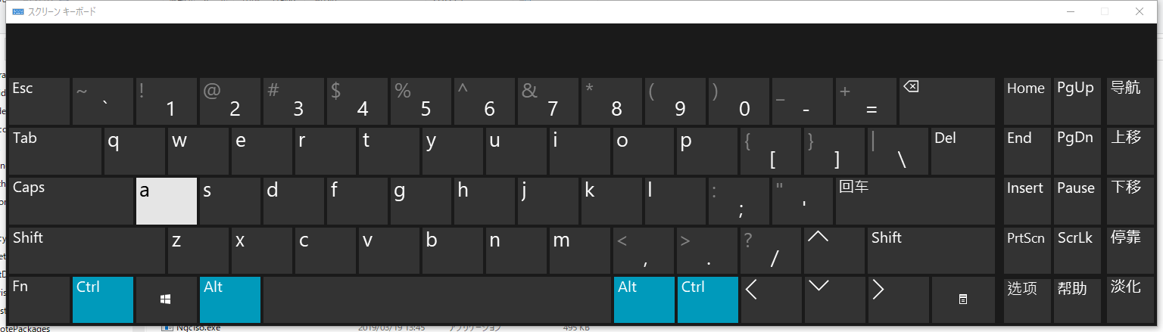

slui.exe

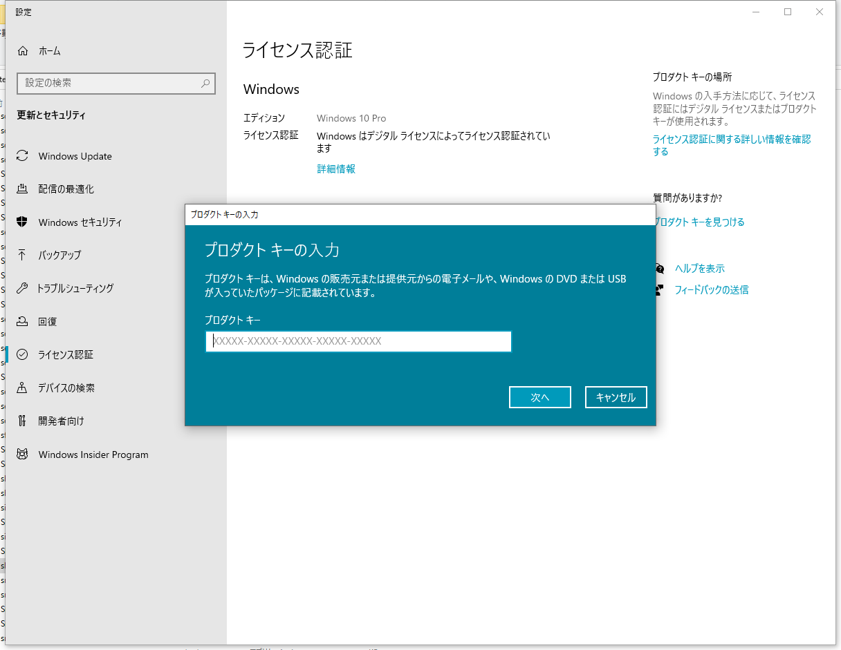

SystemPropertiesComputerName.exe

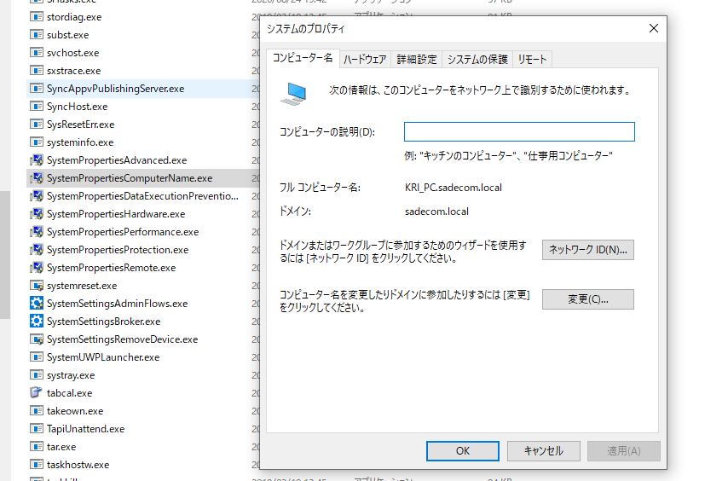

msconfig.exe

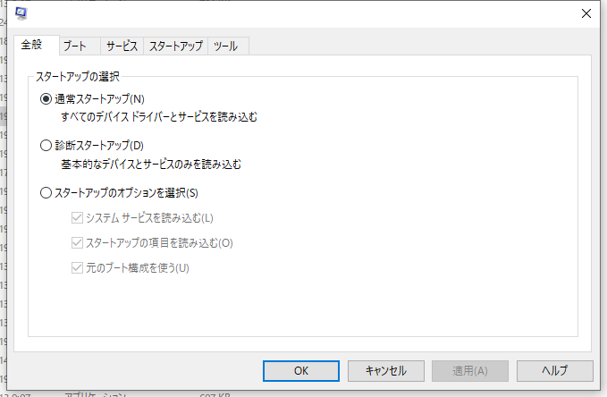

msinfo32.exe

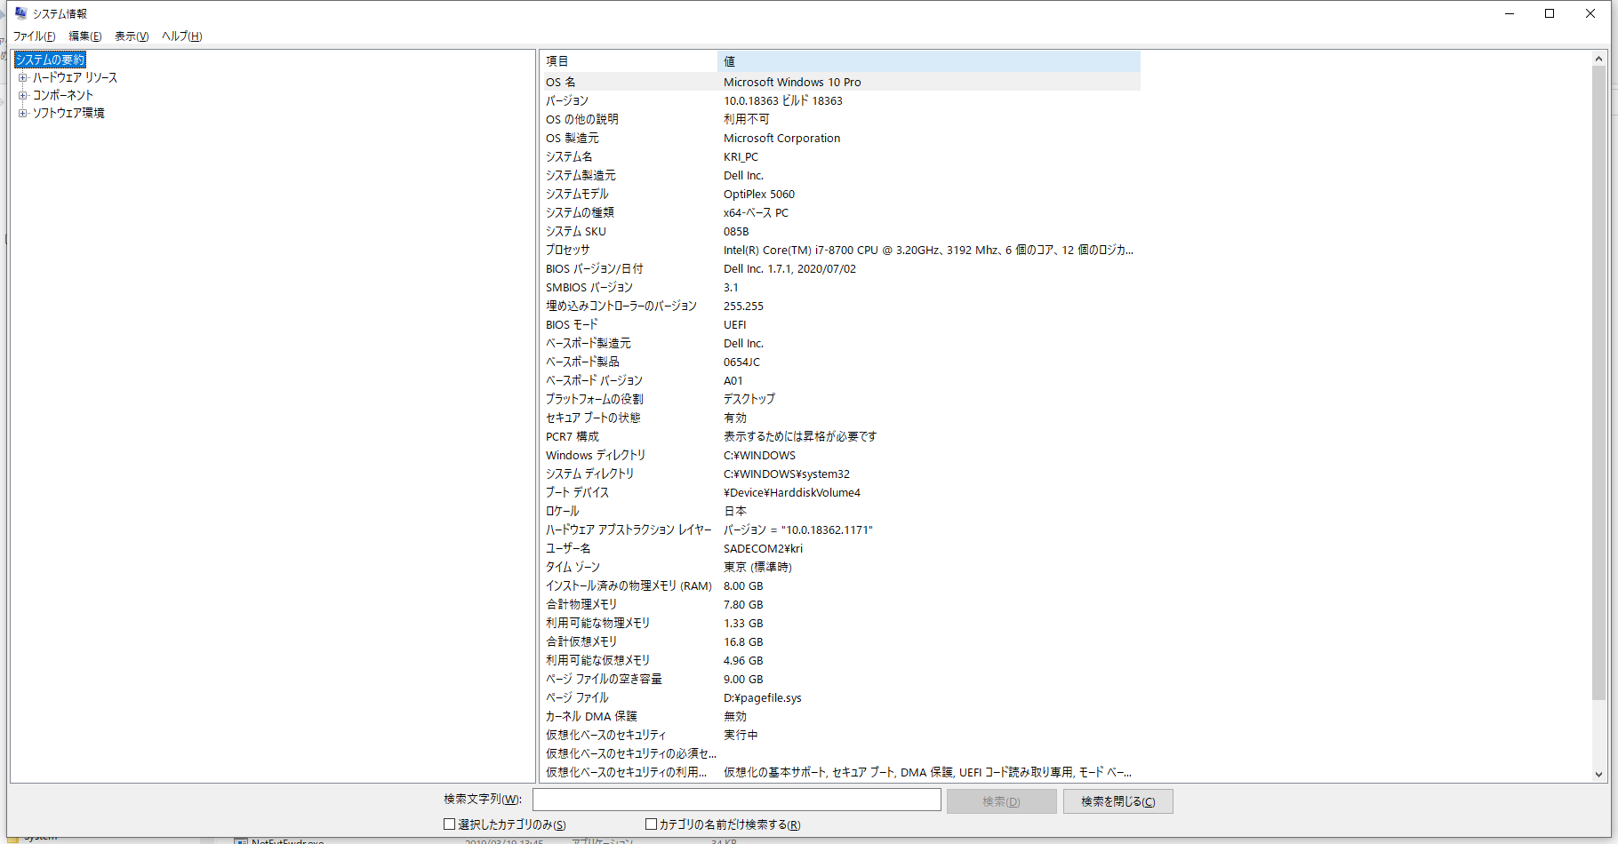

lpksetup.exe

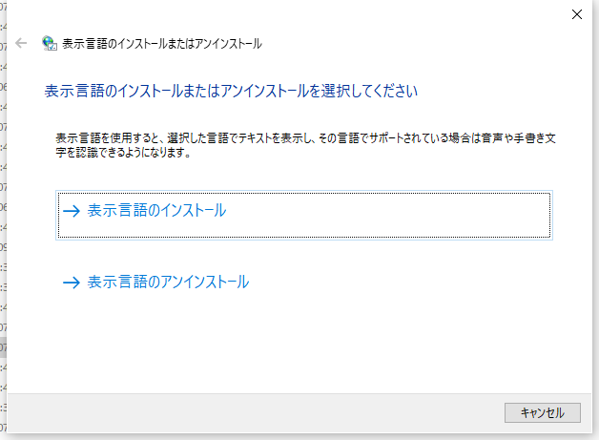



desk.cpl

appwiz.cpl

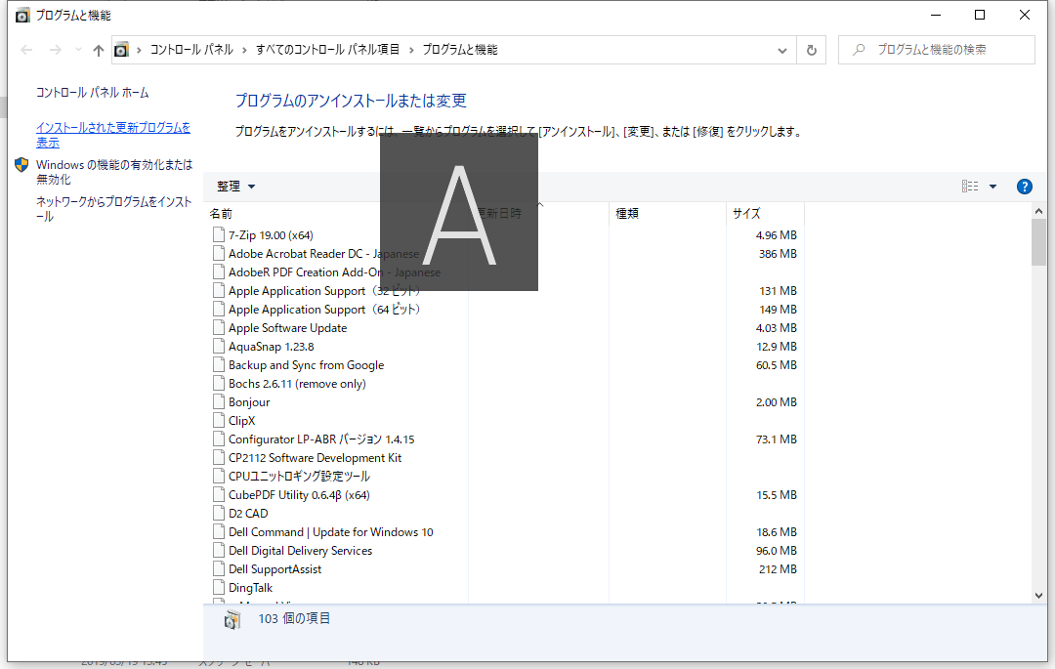

UserAccountControlSettings.exe

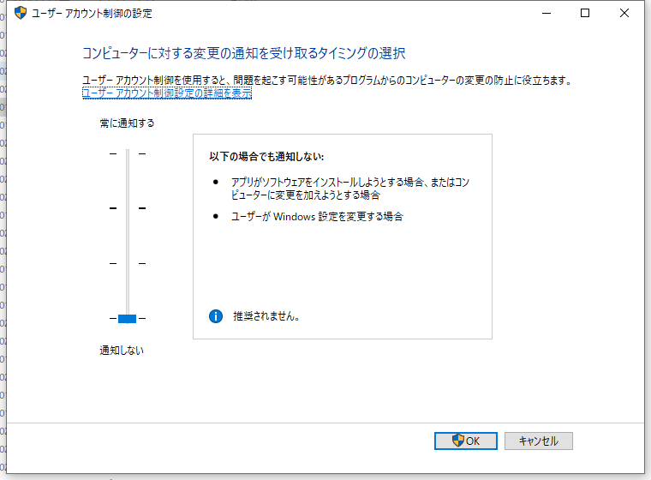

Windows 10 offers the Advanced Startup Options (also known as Advance Boot Options Windows 10) feature to help users to troubleshoot many Windows 10 problems.

After you access Advanced Options Windows 10 menu, you can [**repair Windows 10**](https://www.minitool.com/data-recovery/repair-windows-10-free-009.html) problems with the diagnostic and repair tools it offer. You can use the tools like Reset this PC, Startup Repair, [**System Restore**](https://www.minitool.com/news/use-system-restore-windows-10.html), System Image Recovery, Command Prompt to diagnose and fix Windows 10 errors. You can also access Startup Settings from Windows 10 Advanced options to [**start Windows 10 in Safe Mode**](https://www.minitool.com/data-recovery/how-to-start-windows-10-in-safe-mode-009.html) if your computer has problems to start.

There are many ways to access Advanced Options Windows 10. This post introduces 9 ways to you. Some ways lets you directly get into Windows 10 boot options menu when PC can start, while some others enable you to access Advanced Startup Options Windows 10 when PC/[**laptop won’t turn on**](https://www.minitool.com/data-recovery/fix-my-laptop-wont-turn-on-009.html).

**Way 1. Access Advanced Startup Options Windows 10 from Settings**

If your Windows 10 PC can boot, you can click **Start -> Settings -> Update & Security -> Recovery**, and click **Restart now** button under **Advanced startup** to access Advanced Startup Options window.

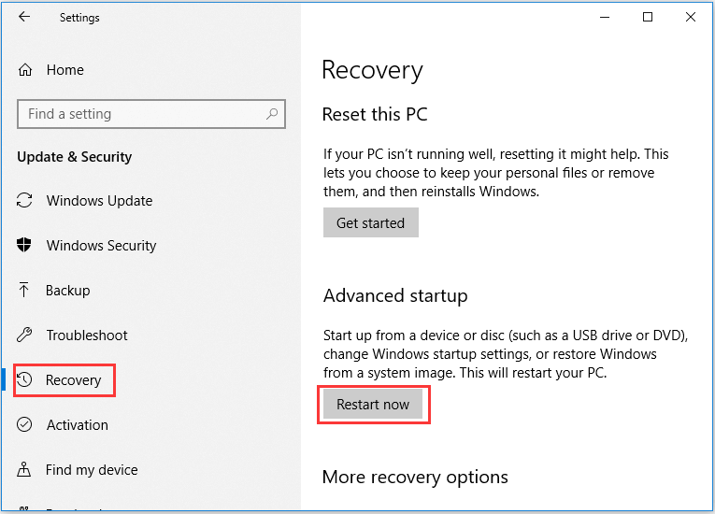

**Way 2. Access Advanced Boot Options Windows 10 with Shift + Restart**

Another easy way to access Advanced Options window is through Shift + Restart. You can click **Start -> Power**, press and hold **Shift** key on the keyboard and click **Restart** button. This will take you into the Advanced Startup Options menu in Windows 10.

**Way 3. Access Advanced Options Windows 10 from Sign-in Screen**

If you are in the sign-in screen, you can click **Power** button at the lower-right. Press and hold **Shift** and click **Restart**. This will also open Advanced Options dialog.

**Way 4. Enter into Advance Options though Task Manager Power Menu**

You can press **Ctrl + Alt + Delete** keys on the keyboard at the same time to open the [**Task Manager**](https://www.minitool.com/lib/task-manager.html) menu. Then click **Power** button, press and hold **Shift** key on the keyboard and click **Restart** button.

**Way 5. Hit F11 to Access Advanced Startup Options Windows 10**

For some computers, you can hit **F11** key on the keyboard as soon as the computer powers on, and this can help you access Advanced Options menu in Windows 10.

**Way 6. Access Windows 10 Boot Options with Command Prompt**

You can also use Command Prompt to access the Advanced Startup Options in Windows 10.

* Press **Windows + R** keys on the keyboard, and type **cmd** in Windows **Run** Press **Shift + Enter** key to run Command Prompt as administrator.
* You can then type this command line: **shutdown. exe /r /o**, and hit **Enter**.
* Click **Close** when you see **You’re about to be signed out**. And after a while, your Windows 10 computer will restart into Windows 10 recovery mode and enter Advanced Option window.

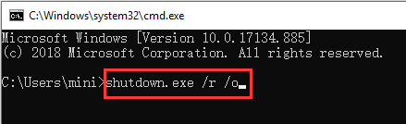

**Way 7. Turn Off and On Windows 10 PC 3 Times to Access Advanced Options**

This way and the following two ways below helps you access Advanced Startup Options Windows 10 when your PC can’t boot.

Press the **Power** button on your computer to start your computer. When you see the Windows logo during booting, immediately press the **Power** button again to shut down the computer. Repeat the power-on and power-off operation 3 times. In the third restart, your computer should enter into Windows Recovery Environment ([**WinRE**](https://www.minitool.com/lib/windows-recovery-environment.html)).

After you select your account and input the account password, you can see the [**Automatic Repair**](https://www.minitool.com/data-recovery/windows-automatic-repair-not-working.html) Window, you can click **Advanced options** button to get to Windows 10 Advanced boot options Window.

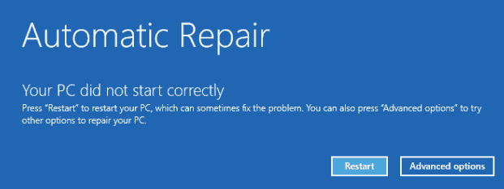

**Way 8. Access Windows 10 Advanced Options with Recovery Drive/Disk**

* If the above ways fail to get you into Advanced Options window, you can create a [**Windows 10 repair/recovery disk**](https://www.minitool.com/data-recovery/windows-10-repair-recovery-disk.html) or USB drive to boot your Windows 10 PC and enter into Windows 10 recovery mode.
* Insert the Windows 10 recovery USB drive or DVD disc to your computer USB port, and boot Windows 10 computer from the Windows 10 recovery drive/disk.
* Then choose a keyboard layout and Windows 10 Advanced Boot Options window will auto open up.

**Way 9. Get to Advanced Options Windows 10 with Installation Disc/Drive**

If you have a Windows 10 [**Installation Disc**](https://www.minitool.com/news/windows-10-installation-disc-vs-recovery-disc-009.html) or USB drive, you can access Windows 10 Advanced Options menu thought installation media.

* Plug in the Windows 10 installation CD/DVD disc or USB flash drive to your computer, and boot the computer from the inserted DVD disc or USB drive in [**BIOS**](https://www.minitool.com/news/how-to-enter-bios-windows-10-8-7-009.html).
* After you enter into **Windows Setup** screen, choose computer language and other preferences and click **Next**.
* Next click **Repair your computer**. Advanced Startup Options window will open.

**Use Advanced Options on Windows 10 to Repair Windows 10 Issues**

By using the 9 ways above, you can easily enter into Advanced Options screen in Windows 10. You can then use the tools in it to troubleshoot and fix your Windows 10 computer problems. You can reset your Windows 10 PC to factory status, perform a system restore to go back to a previous healthy point, boot your computer to [**Safe Mode**](https://www.minitool.com/lib/safe-mode.html), use startup repair to fix Windows 10 startup problems, [**boot to Command Prompt in Windows 10**](https://www.minitool.com/data-recovery/boot-to-command-prompt-windows-10-009.html), etc.

**Description of Control Panel (.cpl) Files**

Summary

This article describes the purpose and usage of Control Panel (.cpl) files.

More Information

Each tool in Control Panel is represented by a .cpl file in the Windows\ System folder. The .cpl files in the Windows\System folder are loaded automatically when you start Control Panel. Note that Control Panel files are sometimes loaded using entries in the [MMCPL] section of the Control.ini file.

The following table lists the most common .cpl files, including all the .cpl files included with Windows:

File name Purpose

-----------------------------------------------------------------------

Access.cpl Accessibility properties

Appwiz.cpl Add/Remove Programs properties

Desk.cpl Display properties

FindFast.cpl FindFast (included with Microsoft Office for Windows 95)

Inetcpl.cpl Internet properties

Intl.cpl Regional Settings properties

Joy.cpl Joystick properties

Main.cpl Mouse, Fonts, Keyboard, and Printers properties

Mlcfg32.cpl Microsoft Exchange or Windows Messaging properties

Mmsys.cpl Multimedia properties

Modem.cpl Modem properties

Network properties

Odbccp32.cpl Data Sources (32-bit ODBC, included w/ Microsoft Office)

Password.cpl Password properties

Sticpl.cpl Scanners and Cameras properties

Sysdm.cpl System properties and Add New Hardware wizard

Themes.cpl Desktop Themes

TimeDate.cpl Date/Time properties

Wgpocpl.cpl Microsoft Mail Post Office

Note that in Windows 98, the Desk.cpl file is named Deskw95.cpl in the compressed cabinet (.cab) file. The file is renamed to Desk.cpl in the Windows\System folder.

Third-party software and hardware manufacturers can add Control Panel icons to provide an interface for setting configuration options for their products. An icon appears in Control Panel when the .cpl file is placed in the Windows\System folder by the program's Setup tool.

You can create a shortcut to a Control Panel tool by dragging an icon from Control Panel to the desktop or another location, or by manually creating a shortcut and specifying the path to a .cpl file.

Note that the Sounds tool does not have its own .cpl file; it uses the Mmsys.cpl file. To create a shortcut to the Sounds tool, use the command line control mmsys.cpl sounds.

## Launch the Windows Settings app

## ms-settings: URI scheme reference

<https://docs.microsoft.com/en-us/windows/uwp/launch-resume/launch-settings-app#network-and-internet>